WEEK 3: Spring REST using Spring Boot 3
Exercise 1: Create a Spring Web Project using Maven
pom.xml
<?xml version="1.0" encoding="UTF-8"?>
<project xmlns="http://maven.apache.org/POM/4.0.0"
xmlns:xsi="http://www.w3.org/2001/XMLSchema-instance"
xsi:schemaLocation="http://maven.apache.org/POM/4.0.0
https://maven.apache.org/xsd/maven-4.0.0.xsd">
<modelVersion>4.0.0</modelVersion
<parent>
<groupId>org.springframework.boot</groupId>
<artifactId>spring-boot-starter-parent</artifactId>
<version>3.5.4</version>
<relativePath/>
</parent>
<groupId>com.example</groupId>
<artifactId>demo</artifactId>
<version>0.0.1-SNAPSHOT</version>
<properties>
<java.version>17</java.version>
</properties>
<dependencies>
<dependency>
<groupId>org.springframework.boot</groupId>
<artifactId>spring-boot-starter-web</artifactId>
</dependency>
<dependency>
<groupId>org.springframework.boot</groupId>
<artifactId>spring-boot-starter-test</artifactId>
<scope>test</scope>
</dependency>
</dependencies>
<build>
<plugins>
<plugin>
<groupId>org.springframework.boot</groupId>
<artifactId>spring-boot-maven-plugin</artifactId>
</plugin>
</plugins>
</build>
</project>
Application.properties:
spring.application.name=demo1

Demo.application:
package com.cognizant.demo1;
import org.springframework.boot.SpringApplication;
import org.springframework.boot.autoconfigure.SpringBootApplication
@SpringBootApplication
public class Demo1Application {
public static void main(String[] args)
SpringApplication.run(Demo1Application.class, args)
}
}
Output:
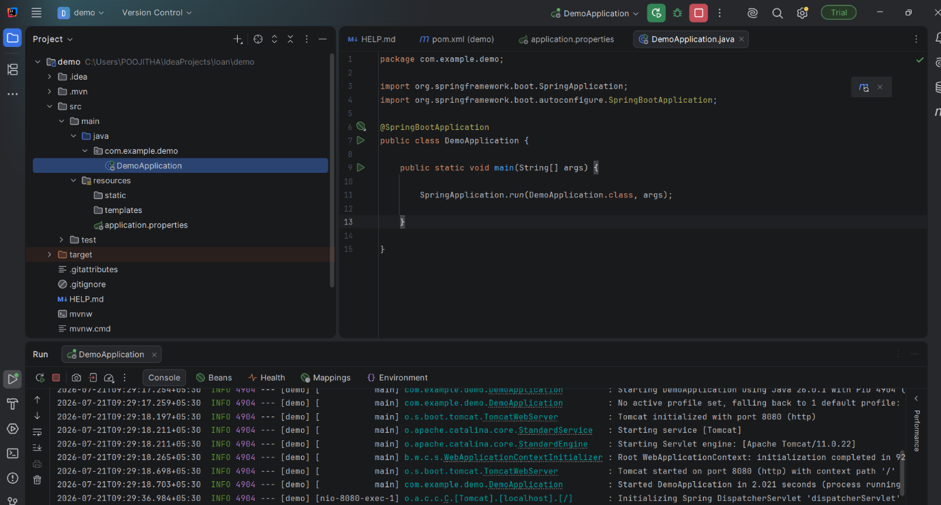

Exercise -2:Spring Core – Load Country from Spring Configuration XML
Pom.xml
<?xml version="1.0" encoding="UTF-8"?>
<project xmlns="http://maven.apache.org/POM/4.0.0"
xmlns:xsi="http://www.w3.org/2001/XMLSchema-instance"
xsi:schemaLocation="http://maven.apache.org/POM/4.0.0 https://maven.apache.org/xsd/maven-4.0.0.xsd">
<modelVersion>4.0.0</modelVersion>
<parent>
<groupId>org.springframework.boot</groupId>
<artifactId>spring-boot-starter-parent</artifactId>
<version>3.5.4</version>
<relativePath/>
</parent>
<groupId>com.cognizant</groupId>
<artifactId>demo1</artifactId>
<version>0.0.1-SNAPSHOT</version>
<properties>
<java.version>17</java.version>
</properties>
<dependencies>
<dependency>
<groupId>org.springframework.boot</groupId>
<artifactId>spring-boot-starter</artifactId>
</dependency>
<dependency>
<groupId>org.springframework</groupId>
<artifactId>spring-context</artifactId>
</dependency>
<dependency>
<groupId>org.springframework.boot</groupId>
<artifactId>spring-boot-starter-test</artifactId>
<scope>test</scope>
</dependency>
</dependencies>
<build>
<plugins>
<plugin>
<groupId>org.springframework.boot</groupId>
<artifactId>spring-boot-maven-plugin</artifactId>
</plugin>
</plugins>
</build>
</project>
Country.java
package com.example.demo1.bean;
public class Country {
private String code;
private String name;
public Country() {
}
public Country(String code, String name) {
this.code = code;
this.name = name;
}
public String getCode() {
return code;
}

public void setCode(String code) {
this.code = code;
}
public String getName() {
return name;
}
public void setName(String name) {
this.name = name;
}
@Override
public String toString() {
return "Country [code=" + code + ", name=" + name + "]";
}
}
country.xml
<?xml version="1.0" encoding="UTF-8"?>
<beans xmlns="http://www.springframework.org/schema/beans"
xmlns:xsi="http://www.w3.org/2001/XMLSchema-instance"
xsi:schemaLocation="

http://www.springframework.org/schema/beans
https://www.springframework.org/schema/beans/spring-beans.xsd">

<bean id="country" class="com.example.demo1.bean.Country">
<property name="code" value="IN"/>

<property name="name" value="India"/>
</bean>
</beans>

CountryService.java
package com.example.demo1.service;
import com.example.demo1.bean.Country;
import org.springframework.context.ApplicationContext;

import org.springframework.context.support.ClassPathXmlApplicationContext;
public class CountryService
{
public Country getCountry() {
ApplicationContext context =
new ClassPathXmlApplicationContext("country.xml");
return (Country) context.getBean("country");
}
}
Demo1Application.java
package com.example.demo1;
import com.example.demo1.bean.Country;
import com.example.demo1.service.CountryService;
import org.springframework.boot.SpringApplication;
import org.springframework.boot.autoconfigure.SpringBootApplication;

@SpringBootApplication
public class Demo1Application {
public static void main(String[] args) {
SpringApplication.run(Demo1Application.class, args);
CountryService service = new CountryService();
Country country = service.getCountry();
System.out.println(country);
}
}

Output:
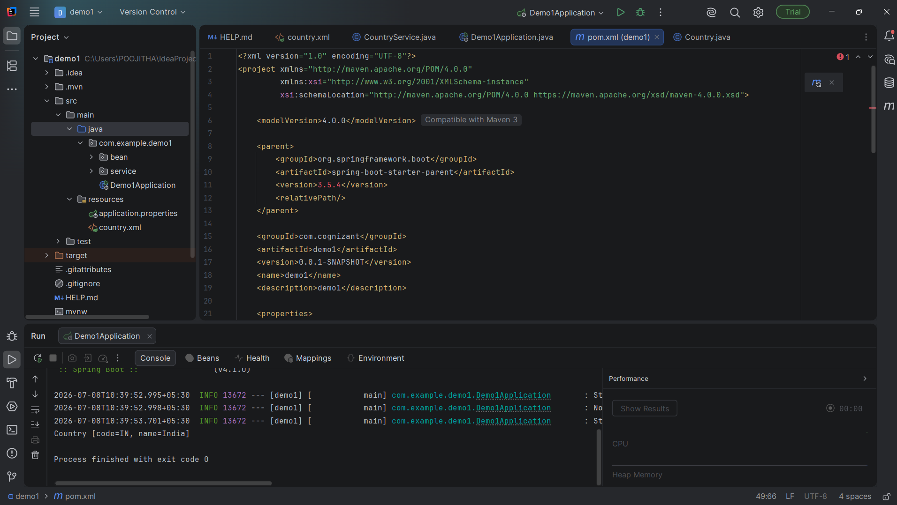
Exercise – 3: Hello World RESTful Web Service
pom.xml
<?xml version="1.0" encoding="UTF-8"?>
<project xmlns="http://maven.apache.org/POM/4.0.0"
xmlns:xsi="http://www.w3.org/2001/XMLSchema-instance"
xsi:schemaLocation="https://maven.apache.org/POM/4.0.0 https://maven.apache.org/xsd/maven-4.0.0.xsd">
<modelVersion>4.0.0</modelVersion>
<parent>
<groupId>org.springframework.boot</groupId>
<artifactId>spring-boot-starter-parent</artifactId>
<version>3.5.3</version>
<relativePath/>
</parent>
<groupId>com.example</groupId>
<artifactId>demo2</artifactId>
<version>0.0.1-SNAPSHOT</version>
<name>demo2</name>
<description>Demo Project</description>
<properties>
<java.version>17</java.version>
</properties>
<dependencies>
<dependency>
<groupId>org.springframework.boot</groupId>
<artifactId>spring-boot-starter-web</artifactId>
</dependency>
<dependency>
<groupId>org.springframework.boot</groupId>
<artifactId>spring-boot-starter-test</artifactId>
<scope>test</scope>
</dependency>
</dependencies>
<build>
<plugins>
<plugin>
<groupId>org.springframework.boot</groupId>
<artifactId>spring-boot-maven-plugin</artifactId>
</plugin>
</plugins>
</build>
</project>
HelloController.java
package com.example.demo.controller;
import org.springframework.web.bind.annotation.GetMapping;
import org.springframework.web.bind.annotation.RestController;
@RestController
public class HelloController {
@GetMapping("/hello")
public String sayHello() {
return "Hello World!!";
}
}
Demo2Application.java
package com.example.demo;
import org.springframework.boot.SpringApplication;
import org.springframework.boot.autoconfigure.SpringBootApplication;
@SpringBootApplication
public class Demo2Application {
public static void main(String[] args) {
SpringApplication.run(Demo2Application.class, args);
}
}
Output:
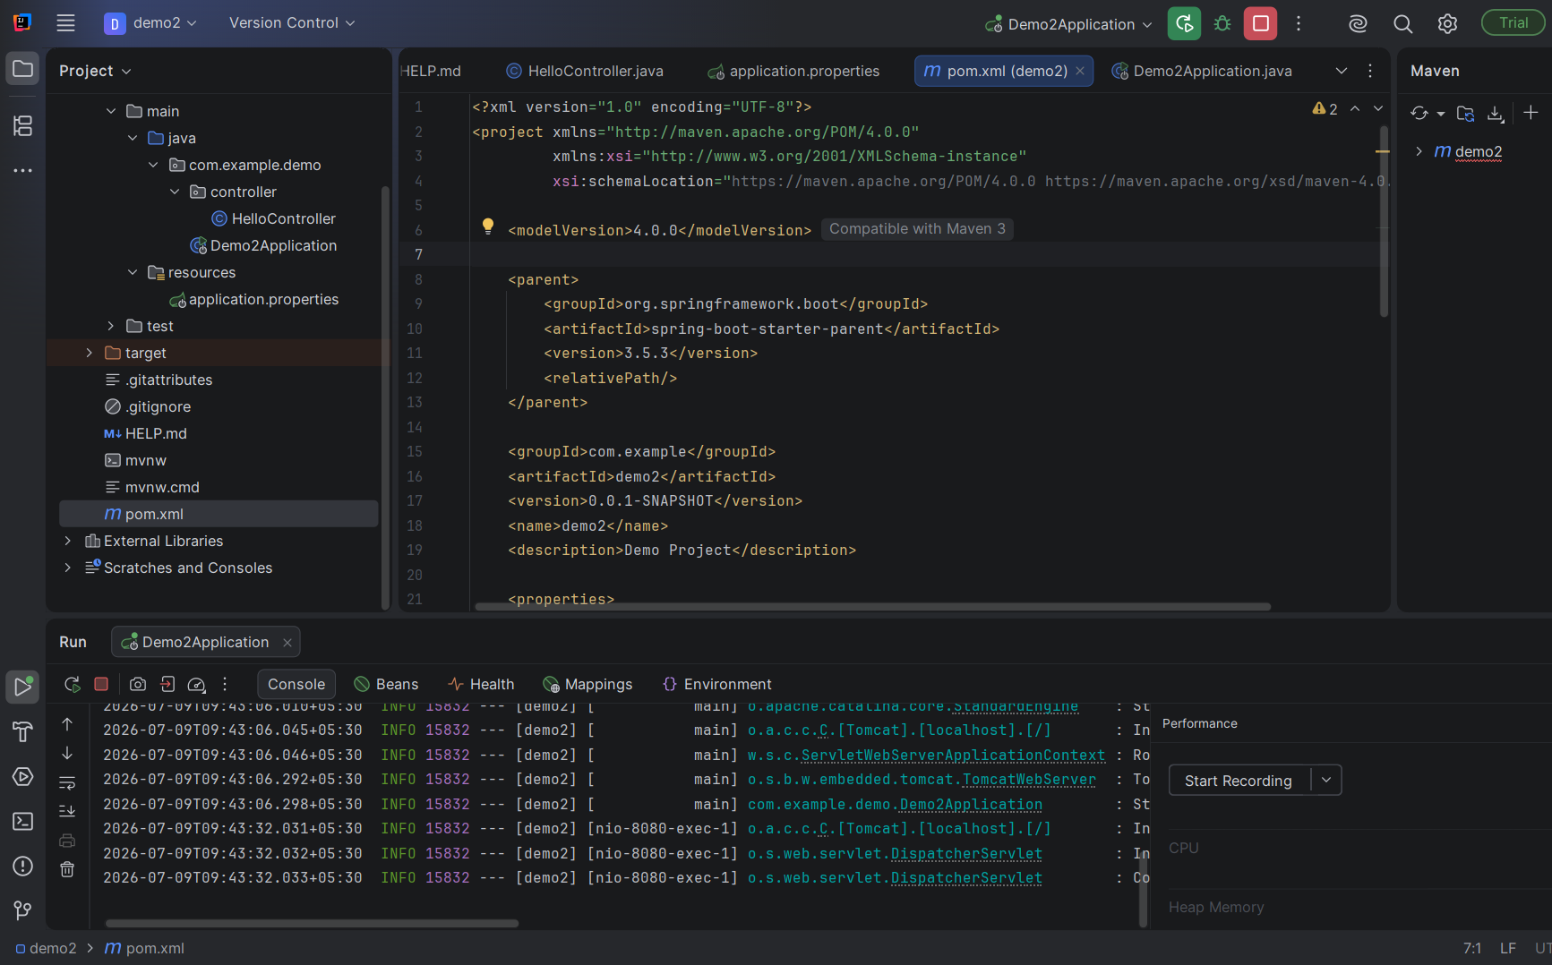

Exercise 4: REST - Country Web Service
Country.java
package com.cognizant.demo4.bean;
public class Country {
private String code;
private String name;
public Country() {
}
public Country(String code, String name) {
this.code = code;
this.name = name;
}
public String getCode() {
return code;
}
public void setCode(String code) {
this.code = code;
}
public String getName() {
return name;
}
public void setName(String name) {
this.name = name;
}
@Override
public String toString() {
return "Country [code=" + code + ", name=" + name + "]";
}
}
CountryController.java
package com.cognizant.demo4.controller;
import com.cognizant.demo4.bean.Country;
import com.cognizant.demo4.service.CountryService;
import org.springframework.beans.factory.annotation.Autowired;
import org.springframework.web.bind.annotation.GetMapping;
import org.springframework.web.bind.annotation.RestController;
@RestController
public class CountryController {
@Autowired
private CountryService countryService;
@GetMapping("/country")
public Country getCountry() {
return countryService.getCountry();
}
}
CountryService:
package com.cognizant.demo4.service;
import com.cognizant.demo4.bean.Country;
import org.springframework.context.ApplicationContext;
import org.springframework.context.support.ClassPathXmlApplicationContext;
import org.springframework.stereotype.Service;
@Service
public class CountryService {
public Country getCountry() {
ApplicationContext context =
new ClassPathXmlApplicationContext("country.xml");
return (Country) context.getBean("country");
}
}
Demo4Application:
package com.cognizant.demo4;
import com.cognizant.demo4.bean.Country;
import com.cognizant.demo4.service.CountryService;
import org.springframework.boot.SpringApplication;
import org.springframework.boot.autoconfigure.SpringBootApplication;
@SpringBootApplication
public class Demo4Application {
public static void main(String[] args) {
SpringApplication.run(Demo4Application.class, args);
CountryService service = new CountryService();
Country country = service.getCountry();
System.out.println(country);
}
}
Application.properties:
spring.application.name=demo4

pom.xml:
<?xml version="1.0" encoding="UTF-8"?>
<project xmlns="http://maven.apache.org/POM/4.0.0"
xmlns:xsi="http://www.w3.org/2001/XMLSchema-instance"
xsi:schemaLocation="http://maven.apache.org/POM/4.0.0 https://maven.apache.org/xsd/maven-4.0.0.xsd">
<modelVersion>4.0.0</modelVersion>
<parent>
<groupId>org.springframework.boot</groupId>
<artifactId>spring-boot-starter-parent</artifactId>
<version>3.5.4</version>
<relativePath/>
</parent>
<groupId>com.cognizant</groupId>
<artifactId>spring-learn</artifactId>
<version>0.0.1-SNAPSHOT</version>
<properties>
<java.version>17</java.version>
</properties>
<dependencies>
<dependency>
<groupId>org.springframework.boot</groupId>
<artifactId>spring-boot-starter-web</artifactId>
</dependency>
<dependency>
<groupId>org.springframework</groupId>
<artifactId>spring-context</artifactId>
</dependency>
<dependency>
<groupId>org.springframework.boot</groupId>
<artifactId>spring-boot-starter-test</artifactId>
<scope>test</scope>
</dependency>
</dependencies>
</project>
country.xml:
<?xml version="1.0" encoding="UTF-8"?>
<beans xmlns="http://www.springframework.org/schema/beans"
xmlns:xsi="http://www.w3.org/2001/XMLSchema-instance"
xsi:schemaLocation="
http://www.springframework.org/schema/beans
https://www.springframework.org/schema/beans/spring-beans.xsd"
<bean id="country"
class="com.cognizant.demo4.bean.Country">
<property name="code" value="IN"/>
<property name=
"name" value="India"/>
</bean>
</beans>
Output:
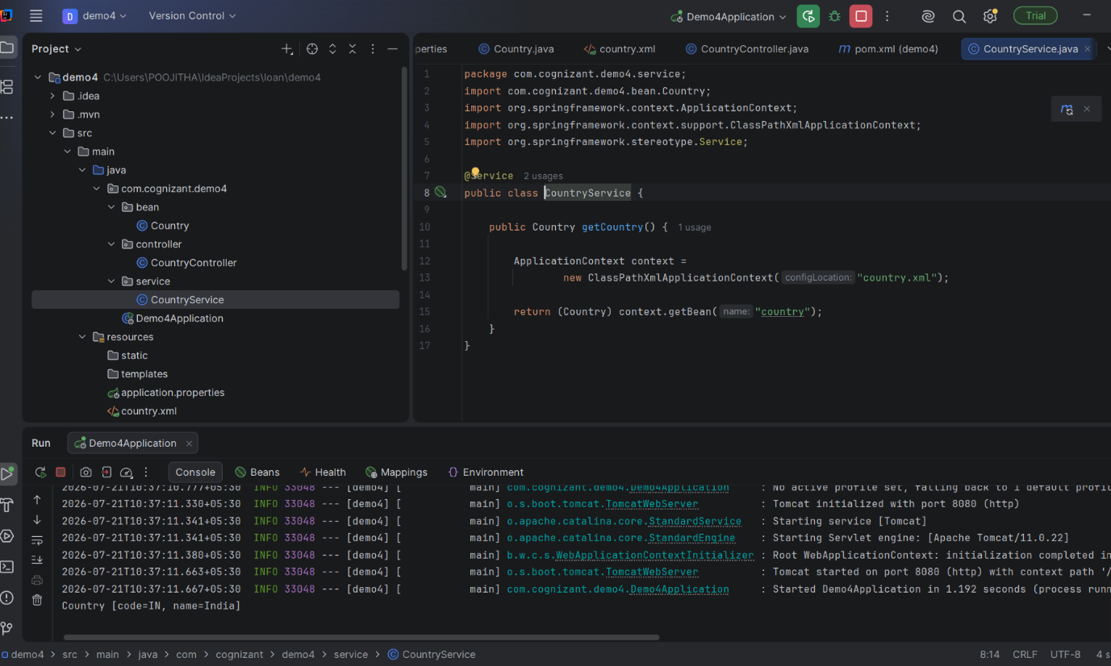
EX 5: Get Country Based on Country Code
CountryController.java
package com.cognizant.springlearn.controller
import org.springframework.web.bind.annotation.*;
import com.cognizant.springlearn.bean.Country;
import com.cognizant.springlearn.service.CountryService;
@RestController
public class CountryController {
private CountryService countryService;
public CountryController(CountryService countryService) {
this.countryService = countryService;
}
@GetMapping("/countries/{code}")
public Country getCountry(@PathVariable String code) {
Country country = countryService.getCountry(code);
System.out.println(country);
return country;
}
}
Country.java
package com.cognizant.springlearn.bean;
public class Country {
private String code;
private String name;
public Country() {
}
public Country(String code, String name) {
this.code = code;
this.name = name;
}
public String getCode() {
return code;
}
public void setCode(String code) {
this.code = code;
}
public String getName() {
return name;
}
public void setName(String name) {
this.name = name;
}
}
CountryService.java
package com.cognizant.springlearn.service
import java.util.ArrayList;
import java.util.List;
import org.springframework.stereotype.Service
import com.cognizant.springlearn.bean.Country;
@Service
public class CountryService
private List<Country> countries = new ArrayList<>();
public CountryService() {
countries.add(new Country("IN", "India"));
countries.add(new Country("US", "United States"));
countries.add(new Country("UK", "United Kingdom"));
countries.add(new Country("CA", "Canada"));
}
public Country getCountry(String code) {
for (Country country : countries) {
if (country.getCode().equalsIgnoreCase(code)) {
return country;
}
}
return null;
}
}
SpringLearnApplication:
package com.cognizant.springlearn;
import org.springframework.boot.SpringApplication;
import org.springframework.boot.autoconfigure.SpringBootApplication;
import org.springframework.context.annotation.ImportResource;
@SpringBootApplication
@ImportResource("classpath:country.xml")
public class SpringLearnApplication {
public static void main(String[] args) {
SpringApplication.run(SpringLearnApplication.class, args);
}
}
pom.xml
<project xmlns="http://maven.apache.org/POM/4.0.0"
xmlns:xsi="http://www.w3.org/2001/XMLSchema-instance"
xsi:schemaLocation="
http://maven.apache.org/POM/4.0.0
https://maven.apache.org/xsd/maven-4.0.0.xsd">
<modelVersion>4.0.0</modelVersion
<parent>
<groupId>org.springframework.boot</groupId>
<artifactId>spring-boot-starter-parent</artifactId>
<version>3.5.4</version>
<relativePath/>
</parent
<groupId>com.cognizant</groupId>
<artifactId>spring-learn</artifactId>
<version>0.0.1-SNAPSHOT</version>
<name>spring-learn</name>
<description>Get Country Based on Country Code</description>
<properties>
<java.version>17</java.version>
</properties>
<dependencies>
<dependency>
<groupId>org.springframework.boot</groupId>
<artifactId>spring-boot-starter-web</artifactId>
</dependency>
<dependency>
<groupId>org.springframework.boot</groupId>
<artifactId>spring-boot-starter-test</artifactId>
<scope>test</scope>
</dependency
</dependencies
<build>
<plugins
<plugin>
<groupId>org.springframework.boot</groupId>
<artifactId>spring-boot-maven-plugin</artifactId>
</plugin>
</plugins>
</build>
</project>

Output:
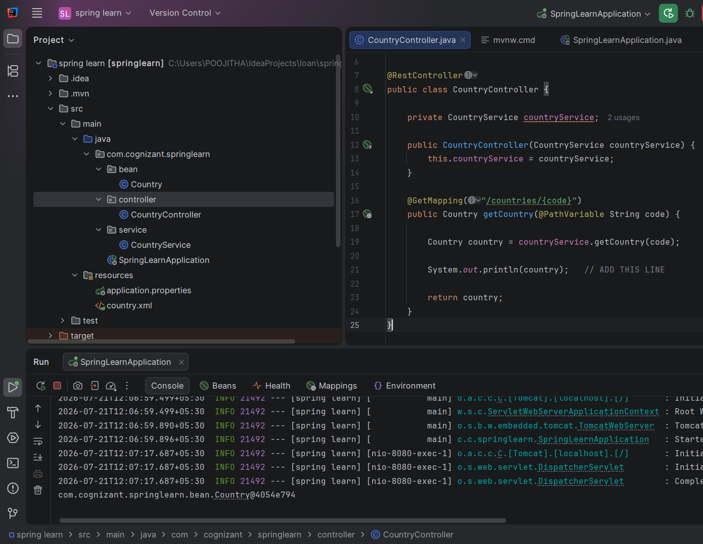
EX 6 : JWT Handson
AuthenticationController:
package com.cognizant.jwthandson.controller;
import java.util.Base64;
import java.util.Date;
import java.util.HashMap;
import java.util.Map;
import org.springframework.web.bind.annotation.GetMapping;
import org.springframework.web.bind.annotation.RequestHeader;
import org.springframework.web.bind.annotation.RestController;
import io.jsonwebtoken.JwtBuilder;
import io.jsonwebtoken.Jwts;
import io.jsonwebtoken.SignatureAlgorithm;
@RestController
public class AuthenticationController {
@GetMapping("/authenticate")
public Map<String,String> authenticate(
@RequestHeader("Authorization") String authHeader) {
String user = getUser(authHeader);
String token = generateJwt(user);
Map<String,String> map = new HashMap<>();
map.put("token", token);
return map;
}
private String getUser(String authHeader) {
String encodedCredentials =authHeader.substring(6);
byte[] decodedBytes =Base64.getDecoder().decode(encodedCredentials);
String credentials =new String(decodedBytes);
return credentials.substring(0, credentials.indexOf(":")
);
}
private String generateJwt(String user) {
JwtBuilder builder =Jwts.builder();
builder.setSubject(user);
builder.setIssuedAt(new Date());
builder.setExpiration(
new Date(System.currentTimeMillis() + 1200000)
);
builder.signWith(
SignatureAlgorithm.HS256,
"secretkey"
);
return builder.compact();
}
}
CountryController:
package com.cognizant.jwthandson.controller;
import org.springframework.web.bind.annotation.GetMapping;
import org.springframework.web.bind.annotation.RestController;
@RestController
public class CountryController {
@GetMapping("/countries")
public String getCountries() {
return "India, Germany, Japan, USA";
}
}
JwtAuthorizationFilter:
package com.cognizant.jwthandson.security;
import java.io.IOException;
import java.util.ArrayList;
import javax.servlet.FilterChain;
import javax.servlet.ServletException;
import javax.servlet.http.HttpServletRequest;
import javax.servlet.http.HttpServletResponse;
import org.springframework.security.authentication.AuthenticationManager;
import org.springframework.security.authentication.UsernamePasswordAuthenticationToken;
import org.springframework.security.core.context.SecurityContextHolder;
import org.springframework.security.web.authentication.www.BasicAuthenticationFilter;
import io.jsonwebtoken.Claims;
import io.jsonwebtoken.Jws;
import io.jsonwebtoken.JwtException;
import io.jsonwebtoken.Jwts;
public class JwtAuthorizationFilter extends BasicAuthenticationFilter {
public JwtAuthorizationFilter(AuthenticationManager authenticationManager) {
super(authenticationManager);
}
@Override
protected void doFilterInternal(
HttpServletRequest request,
HttpServletResponse response,
FilterChain chain)
throws IOException, ServletException {
String header = request.getHeader("Authorization");
if (header == null || !header.startsWith("Bearer ")) {
chain.doFilter(request, response);
return;
}
UsernamePasswordAuthenticationToken authentication =
getAuthentication(request){
if(authentication != null) {
SecurityContextHolder
.getContext()
.setAuthentication(authentication);
}
chain.doFilter(request, response);
}
private UsernamePasswordAuthenticationToken getAuthentication(
HttpServletRequest request) {
String token = request.getHeader("Authorization");
try {
Jws<Claims> jws =Jwts.parser().setSigningKey("secretkey").parseClaimsJws(token.replace("Bearer ", "")
);
String user =jws.getBody() .getSubject();
if(user != null) {
return new UsernamePasswordAuthenticationToken(user,null,new ArrayList<>()
);
}
}
catch (JwtException e) {
return null;
}
return null;
}
}
SecurityConfig:
package com.cognizant.jwthandson.security;
import org.springframework.context.annotation.Bean;
import org.springframework.context.annotation.Configuration;
import org.springframework.security.config.annotation.web.builders.HttpSecurity;
import org.springframework.security.core.userdetails.User;
import org.springframework.security.core.userdetails.UserDetails;
import org.springframework.security.crypto.bcrypt.BCryptPasswordEncoder;
import org.springframework.security.crypto.password.PasswordEncoder;
import org.springframework.security.provisioning.InMemoryUserDetailsManager;
import org.springframework.security.web.SecurityFilterChain;
@Configuration
public class SecurityConfig {
@Bean
public InMemoryUserDetailsManager userDetailsService() {
UserDetails user = User.builder()
.username("user")
.password(passwordEncoder().encode("pwd"))
.roles("USER")
.build();
UserDetails admin = User.builder()
.username("admin")
.password(passwordEncoder().encode("pwd"))
.roles("ADMIN")
.build();
return new InMemoryUserDetailsManager(user, admin);
}
@Bean
public PasswordEncoder passwordEncoder() {
return new BCryptPasswordEncoder();
}
@Bean
public SecurityFilterChain filterChain(HttpSecurity http) throws Exception {
http
.csrf().disable()
.authorizeRequests()
.antMatchers("/authenticate").permitAll()
.anyRequest().authenticated()
.and()
.httpBasic();
return http.build();
}
}
JwtHandsonApplication:
package com.cognizant.jwthandson;
import org.springframework.boot.SpringApplication;
import org.springframework.boot.autoconfigure.SpringBootApplication;
@SpringBootApplication
public class JwtHandsonApplication {
public static void main(String[] args) {
SpringApplication.run(JwtHandsonApplication.class, args);
}
}
pom.xml:
<?xml version="1.0" encoding="UTF-8"?>
<project xmlns="http://maven.apache.org/POM/4.0.0"
xmlns:xsi="http://www.w3.org/2001/XMLSchema-instance"
xsi:schemaLocation="https://maven.apache.org/POM/4.0.0 https://maven.apache.org/xsd/maven-4.0.0.xsd">
<modelVersion>4.0.0</modelVersion>
<parent>
<groupId>org.springframework.boot</groupId>
<artifactId>spring-boot-starter-parent</artifactId>
<version>2.7.18</version>
<relativePath/>
</parent>
<groupId>com.cognizant</groupId>
<artifactId>JWT-handson</artifactId>
<version>0.0.1-SNAPSHOT</version>
<name>JWT-handson</name>
<description>JWT Authentication Hands-on</description>
<properties>
<java.version>17</java.version>
</properties>
<dependencies>
<dependency>
<groupId>org.springframework.boot</groupId>
<artifactId>spring-boot-starter-web</artifactId>
</dependency>
<dependency>
<groupId>org.springframework.boot</groupId>
<artifactId>spring-boot-starter-security</artifactId>
</dependency>
<dependency>
<groupId>io.jsonwebtoken</groupId>
<artifactId>jjwt</artifactId>
<version>0.9.1</version>
</dependency>
<dependency>
<groupId>javax.xml.bind</groupId>
<artifactId>jaxb-api</artifactId>
<version>2.3.1</version>
</dependency>
<dependency>
<groupId>org.glassfish.jaxb</groupId>
<artifactId>jaxb-runtime</artifactId>
<version>2.3.8</version>
</dependency>
<dependency>
<groupId>org.springframework.boot</groupId>
<artifactId>spring-boot-starter-test</artifactId>
<scope>test</scope>
</dependency>
</dependencies>
<build>
<plugins>
<plugin>
<groupId>org.springframework.boot</groupId>
<artifactId>spring-boot-maven-plugin</artifactId>
</plugin>
</plugins>
</build>
</project>

Output:
